Meeting Agenda
Friday, June 14, 2024
Teams Link will be emailed for Virtual attendance.
Attendance:

- Call to Order – TIME - 5 minutes
  - Establish Quorum

  - Welcome/Introductions

  - Adoption of Meeting minutes from April – send out for everyone to review.
Discussion/Summary:
Motion:
Action:

  - Conflict of Interest Disclosure
Discussion/Summary:

- Education Session: Poison Control - Dr. Matousheck presented topic of Cannabis and Pediatrics.

- President’s Report – 5 minutes Sept 4 – 7 with GA 9/3 -9/4
EN 5K in October.
Website – the board is looking into other options.

- Treasurer’s Report – 5 minutes
Larry provided report
Charitable contribution – Southwest Mo Nurse Honor Guard
Education was for the Human Trafficking course
Money Market account shows good income.

- Committee Reports and Discussion– 40 minutes
  - Compliance Kat – May 15

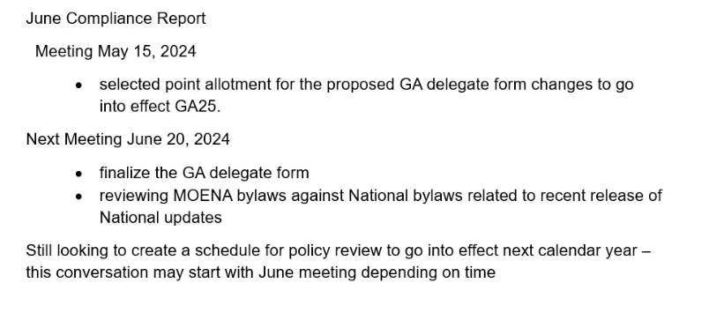National just sent out bylaw update.
Delegate form confusion – if questions send Kat an email before next Thursday.
  - Course Ops -- Angie gave update Judy and Helen have stepped down from their positions. Board will meet to determine how to best fill positions.
  - Education -- Approx 100 folks showed up. 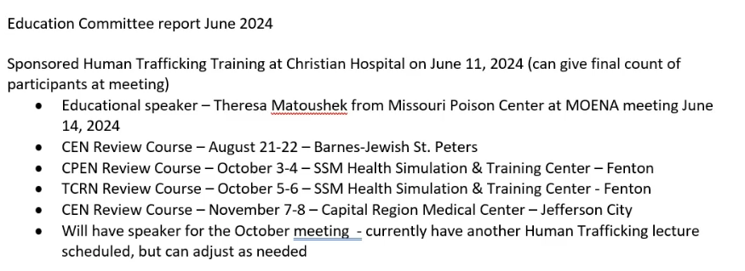
  - Government Affairs Samuel – will send report
DOTH in April -
- QSIP/ Nursing and Advanced Practice -- report attached
  - Marketing/PR
We now have the Step & Retreat (photo booth) for MOENA
MOENA stickers to place on the stop the bleed kits that we are providing.
Planning EN week outreach activities.
  - Membership

Ben --
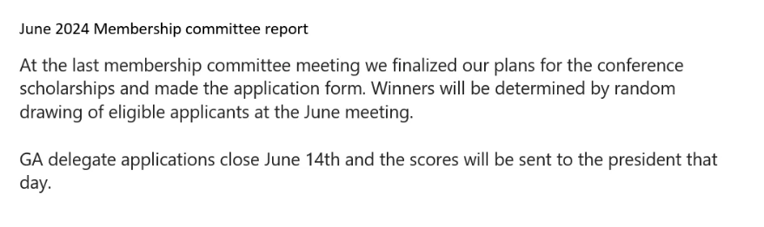
  - Workplace Violence Taskforce
Samuel is looking for more members for the committee.
Doodle poll being conducted today; base level survey is completed.
- Unfinished Business – 10 minutes
  - Conference Scholarship – Due today June 14th --- 6 applicants thus far.
  - Delegate Application – Due today June 14th 17 submitted thus far for 12 seats and an alternate. - will know by Monday
  - In-person meeting discussion/Frequency of meetings -- working on finalizing the plan for 2025
- New Business – 45 minutes
  - Updates from DOTH – nothing new to add
  - Delegate applications – Revisions for 2025

- Open Discussion
- Next Meeting:

- August 9, 2024, in Cape Girardeau, MO – Poll coming for in-person vs. virtual

- Meeting Adjourned

Marketing Report
06/07/2024
Submitted by: Larry Faulkner
Marketing committee met in April 2024 to continue progress towards goals:
Support committees by providing MOENA branded marketing materials as requested.
Provide at least 25% MO Emergency Departments with MOENA branded materials throughout the year.
Investigate and provide the MOENA Board of Directors with a recommendation on an agency to manage MOENA social media and website by August 31, 2024.
We made the decision to purchase a Step & Repeat (fancy name for photo booth back drop) and props for a MOENA photo booth. This allowed up to provide a photo booth at the Human Trafficking Training that we sponsored on June 11 at Christian Hospital in Florissant, MO. Additionally, we provided give-a-ways for this training to support our marketing efforts.
We have ordered stickers with our logo to be placed on the Stop the Bleed kits being provided to the community by the QSIP committee so that when these are distributed, there is an awareness of our organization.
Our next meeting is scheduled for June 18, 2024 and we will be working to finalize our ED outreach program for EN Week.

Course Operations Committee Report
June 11, 2024
Attendance: Helen Sandkuhl, Donna Pond, Tommy Emory, Angela Boren, Kelly Riedel, Kristin Dawson, Christine Fenwick.
I would like to take this time on the agenda to give you all an update on the success of the Course Operations Committee for the last 2 years. In 2022 the Missouri ENA Board of Directors tasked us to expand the Faculty Role in Missouri. Since that time, we have over doubled the state faculty in Missouri for both TNCC and ENPC. We developed a State Faculty application form including all the requirements listed in the updated Course Administration Guidelines to assist in obtaining more applicants. During the same period, we created the ENPC Grant Program, and this year expanded the program to include TNCC Provider Courses to Critical Access Hospitals. We created a voucher program to increase the number of students in the program. This voucher program assisted rural nurses to attend classes free of charge at any class in Missouri without having to wait for courses to come to their area. In 2023 we provided 13 Instructor Courses in Missouri. Seven Instructor Courses were ENPC and six were TNCC Instructor Courses. Courses were held in Kansas City, St. Louis, Springfield, Hannibal, and Columbia. In 2024, we have a total of 17 Instructor Courses scheduled. Eight courses were TNCC Instructor Courses and nine were ENPC Instructor Courses. Courses are planned to be held in Kansas City, St. Louis, Columbia, and Springfield.
Regarding the state faculty application, we must follow the Administrative Rules and candidates who do not meet the requirements will have to continue to work toward faculty status and meet the requirements before the designation can be given (Length as an instructor, number of courses taught).
The Course Operations Committee is also one of the only revenues producing committees other than the Education and Membership Committee. We are the only committee that raises funds for the Treasury through state sponsored courses. These courses provide thousands of dollars annually without compensation to the Course Director or Instructors. This includes providing free postage and food.
The members of this committee have gone above and beyond to make this one of the most successful committees for MOENA. Thank you all.

Quality, Safety, Injury Prevention, and Advanced Practice
5.10.24 11am-12pm

Chair: Nina Arnold
Co-Chair: Rachel Kestner
Attendees: Pam Jackson, Lori, Viktorya, Nina Arnold

Goals 2024:
- Aggregate boarding best practices for 2024.
- Sponsor courses across state for Stop the Bleed Day.
- Host a class for Advanced Practice Nurses to practice suturing skills by the end of summer 2024.
Meeting Notes:

Quality Safety Goal:
- Boarding – no updates on articles. Pam sending out some to review for next meeting.

Injury Prevention:
- MO regions – split up regions for each person to reach out to contacts for courses
  - Pam Jackson – KC (NE MO)
  - Lori – Rural NW MO
  - Kate – Adair Co (NE MO), Miller/Camden Co (central MO), Farmington (SE MO)
  - Rachel – Deep Water (SW MO)
- Plan to purchase kit give aways. Reaching out to instructors in regions to determine numbers to purchase.

Advanced Practice:
- APC Suturing Skills Course
- Pam – St. Luke’s
  - Has trauma surgeon lined up for suturing class
  - St. Luke’s to host western MO course.
  - Reaching out to work on booking and costs.

- Shannon Miller - STL
  - BJH – host an eastern MO course?
  - Reaching out to Trauma surgeon for STL course
  - Nina to follow up with Shannon.
- Cost of course and total supplies:
  - Rachel – looking through the course she attended to see what supplies are needed.
  - Rachel – course she attended in Nashville in 2023 was 2 days and cost $495

Next meeting date scheduled emailed out on teams is 07/12/24 11am-12pm

